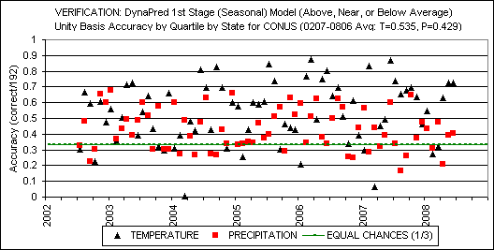
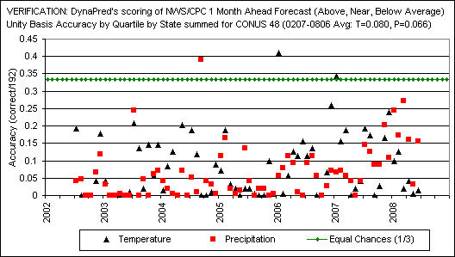
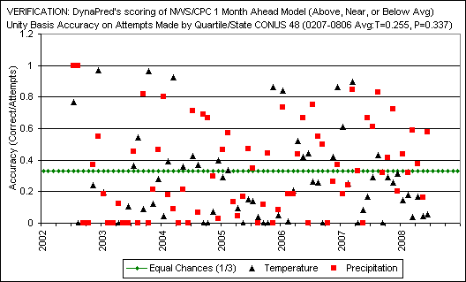

Meaning: DynaPred’s 1st Stage Model predicted temperature and precipitationscored better than breakeven over 72 months at 112/144 (7/9 or 0.7778 unity basis or 77.78%). The 200806 scored predictions were made during 200301 with data ending 200212, i.e., 66 months ahead. Using the same scoring, NWS/CPC predicting one month ahead at a time scored 3/144 (1/48 or 0.0208 unity basis or 2.08%). CPC Correct/Attempted scoring was 54/144 above 1/3 breakeven. DynaPred trends over 6 years: temperature sideways to slightly up, precipitation sideways to slightly down. CPC has improved precipitation and temperatures accuracy from about 200601.

